# Project Design Phase-I Solution Architecture

|  |  |
| --- | --- |
| Date | 29 September 2022 |
| Team ID | PNT2022TMID24924 |
| Project Name | Project – Smart farmer-IoT enabled smart  farming application. |
| Maximum Marks | 4 Marks |

# Solution Architecture Diagram:

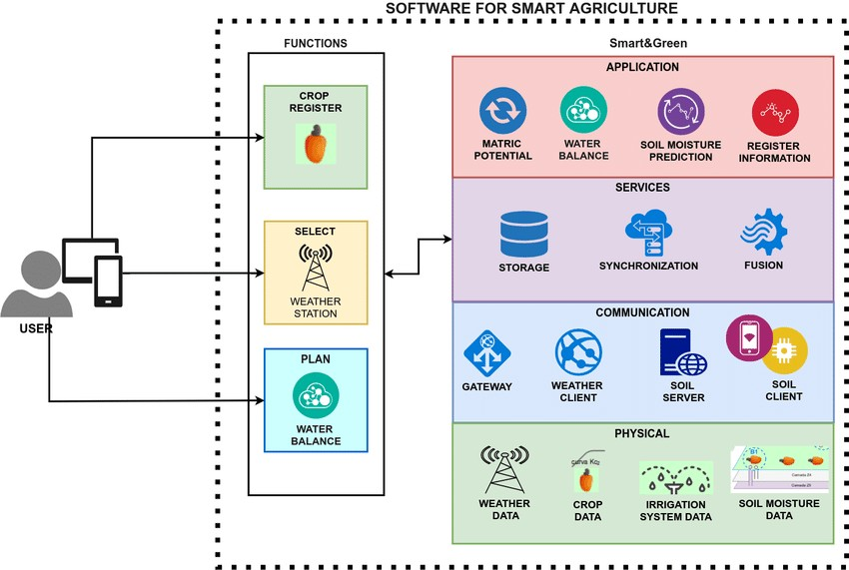

1.The different soil parameters (temperature, humidity, Soil Moisture) are sensed using different sensors, and the obtained value is stored in the IBM cloud.

2. Node-red is used as a programming tool to wire the hardware, software, and APIs.

3. Arduino UNO is used as a processing unit that processes the data obtained from sensors and weather data from weather API.